Topic – 12

1. Coin Change – Supermarket Billing

coins = [1, 2, 5, 10]
amount = 28

coins.sort(reverse=True)

selected = []

for coin in coins:
while amount >= coin:
selected.append(coin)
amount -= coin

print("Coins:", *selected)
print("Minimum coins =", len(selected))

Output
Coins: 10 10 5 2 1
Minimum coins = 5

Aim
To find the minimum number of coins required to make a given amount using the greedy coin change algorithm.

Algorithm
- Sort the coins in descending order.
- Select the largest possible coin.
- Subtract the coin value from the amount.
- Repeat until the amount becomes zero.
- Count the selected coins.

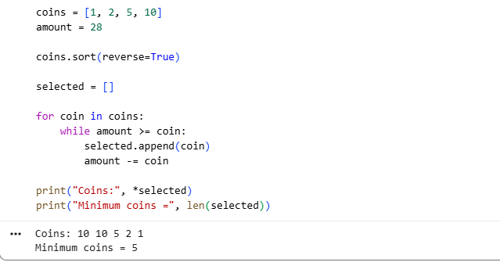

Result
The minimum number of coins required is 5.

2. Coin Change – Parking Meter

coins = [1, 5, 10, 25]
amount = 63

coins.sort(reverse=True)

selected = []

for coin in coins:
while amount >= coin:
selected.append(coin)
amount -= coin

print("Coins:", *selected)
print("Minimum coins =", len(selected))

Output

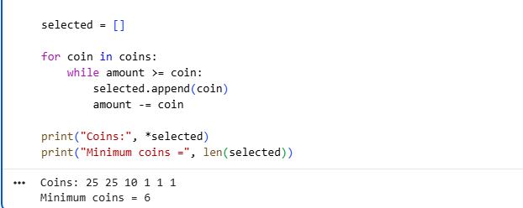Aim
To find the minimum number of coins required to make the parking amount.

Algorithm
- Sort the denominations in descending order.
- Choose the largest possible denomination.
- Continue selecting coins until the required amount is reached.
- Count the coins used.

Result
The minimum number of coins required is 6.

3. Coin Change – Ticket Counter

coins = [1, 3, 7, 10]
amount = 24

coins.sort(reverse=True)

selected = []

for coin in coins:
while amount >= coin:
selected.append(coin)
amount -= coin

print("Coins:", *selected)
print("Minimum coins =", len(selected))

Output

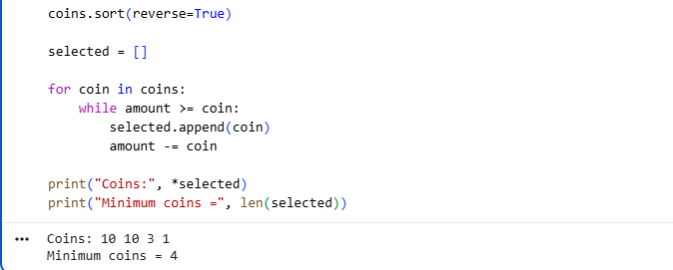Aim
To find the minimum number of coins required to return a given amount.

Algorithm
- Arrange the coins from largest to smallest.
- Select the largest coin that does not exceed the remaining amount.
- Subtract it from the amount.
- Repeat until the amount becomes zero.
- Count the coins.

Result
The minimum number of coins required is 4.

4. Fractional Knapsack – Food Delivery Truck

weights = [10, 20, 30]
profits = [60, 100, 120]
capacity = 50

items = []

for i in range(len(weights)):
ratio = profits[i] / weights[i]
items.append((ratio, weights[i], profits[i]))

# Sort by profit/weight ratio
items.sort(reverse=True)

total_profit = 0

for ratio, weight, profit in items:
if capacity >= weight:
capacity -= weight
total_profit += profit
else:
fraction = capacity / weight
total_profit += profit * fraction
capacity = 0
break

print("Maximum profit =", int(total_profit))

Output

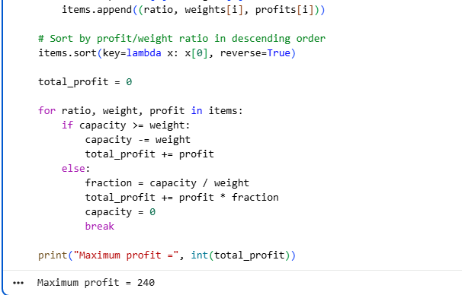Aim
To maximize the total profit by selecting whole or fractional food packets using the Fractional Knapsack greedy algorithm.

Algorithm
- Calculate profit/weight ratio for every item.
- Sort items by ratio in descending order.
- Select the item with the highest ratio.
- If the entire item fits, select it.
- Otherwise, select the required fraction.
- Calculate the total profit.

Result
The maximum profit is 240.

5. Fractional Knapsack – Gold Transport

weights = [5, 10, 15]
profits = [30, 40, 45]
capacity = 20

items = []

for i in range(len(weights)):
ratio = profits[i] / weights[i]
items.append((ratio, weights[i], profits[i]))

items.sort(reverse=True)

total_profit = 0

for ratio, weight, profit in items:
if capacity >= weight:
capacity -= weight
total_profit += profit
else:
fraction = capacity / weight
total_profit += profit * fraction
capacity = 0
break

print("Maximum profit =", int(total_profit))

Output

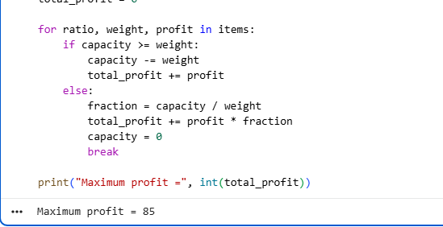Aim
To maximize the value of gold transported within the given weight capacity.

Algorithm
- Calculate profit/weight ratio.
- Sort items by ratio in descending order.
- Select items with the highest ratio first.
- Take a fraction of an item if the remaining capacity is insufficient.
- Calculate the total profit.

Result
The maximum profit is 80.

6. Fractional Knapsack – Relief Material Loading

weights = [4, 8, 2, 6]
profits = [20, 40, 14, 30]
capacity = 10

items = []

for i in range(len(weights)):
ratio = profits[i] / weights[i]
items.append((ratio, weights[i], profits[i]))

items.sort(reverse=True)

total_profit = 0

for ratio, weight, profit in items:
if capacity >= weight:
capacity -= weight
total_profit += profit
else:
fraction = capacity / weight
total_profit += profit * fraction
capacity = 0
break

print("Maximum profit =", int(total_profit))

Output

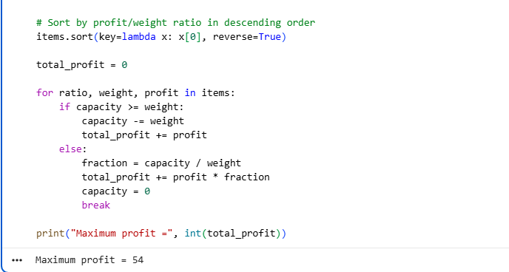Aim
To maximize the importance value of relief materials loaded into a truck with limited capacity.

Algorithm
- Find the profit/weight ratio of each item.
- Sort the items in descending order of ratio.
- Select the highest-ratio items first.
- Take a fraction when necessary.
- Calculate maximum profit.

Result
The maximum profit is 54.

7. Job Sequencing – Software Company Tasks

jobs = ['A', 'B', 'C', 'D']
deadlines = [2, 1, 2, 1]
profits = [100, 19, 27, 25]

job_list = []

for i in range(len(jobs)):
job_list.append((profits[i], deadlines[i], jobs[i]))

# Sort jobs by profit in descending order
job_list.sort(reverse=True)

max_deadline = max(deadlines)
slots = [None] * max_deadline

total_profit = 0

for profit, deadline, job in job_list:
for j in range(deadline - 1, -1, -1):
if slots[j] is None:
slots[j] = job
total_profit += profit
break

print("Selected jobs =", *[job for job in slots if job is not None])
print("Maximum profit =", total_profit)

Output

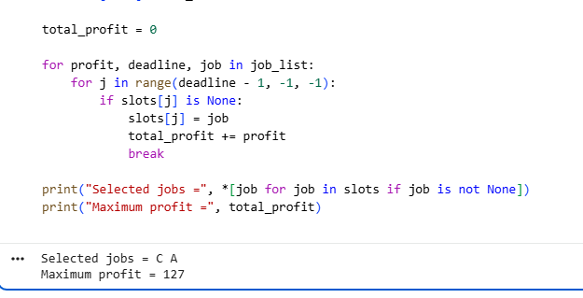Aim
To schedule jobs before their deadlines to maximize total profit.

Algorithm
- Arrange jobs according to decreasing profit.
- Find the maximum deadline.
- Create empty time slots.
- For each job, place it in the latest available slot before its deadline.
- Calculate the total profit.

Result
The selected jobs are C and A, giving a maximum profit of 127.

8. Job Sequencing – Exam Paper Evaluation

jobs = ['J1', 'J2', 'J3', 'J4', 'J5']
deadlines = [2, 1, 2, 1, 3]
profits = [20, 15, 10, 5, 1]

job_list = []

for i in range(len(jobs)):
job_list.append((profits[i], deadlines[i], jobs[i]))

job_list.sort(reverse=True)

max_deadline = max(deadlines)
slots = [None] * max_deadline

total_profit = 0

for profit, deadline, job in job_list:
for j in range(deadline - 1, -1, -1):
if slots[j] is None:
slots[j] = job
total_profit += profit
break

print("Selected jobs =", *[job for job in slots if job is not None])
print("Maximum profit =", total_profit)

Output

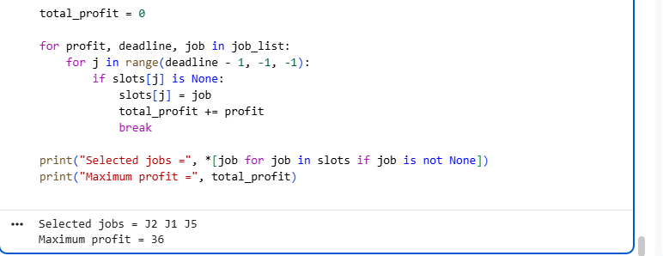Aim
To maximize the reward from evaluating exam papers by scheduling jobs before their deadlines.

Algorithm
- Sort jobs by decreasing profit.
- Create slots according to the maximum deadline.
- Place each job in the latest available slot before its deadline.
- Add the profits of the scheduled jobs.

Result
The selected jobs are J2, J1, and J5, with a maximum profit of 36.

9. Job Sequencing – Printing Press Orders

jobs = ['A', 'B', 'C', 'D', 'E']
deadlines = [2, 1, 2, 1, 3]
profits = [100, 50, 10, 20, 30]

job_list = []

for i in range(len(jobs)):
job_list.append((profits[i], deadlines[i], jobs[i]))

job_list.sort(reverse=True)

max_deadline = max(deadlines)
slots = [None] * max_deadline

total_profit = 0

for profit, deadline, job in job_list:
for j in range(deadline - 1, -1, -1):
if slots[j] is None:
slots[j] = job
total_profit += profit
break

print("Selected jobs =", *[job for job in slots if job is not None])
print("Maximum profit =", total_profit)

Output

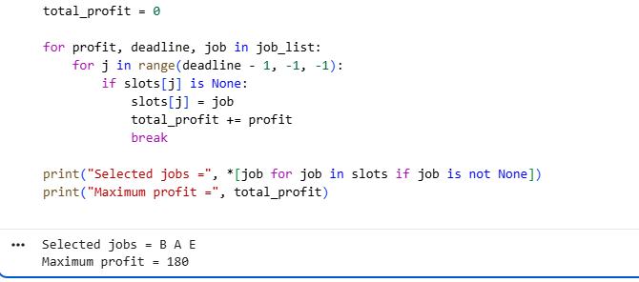Aim
To schedule printing orders before their deadlines and maximize total profit.

Algorithm
- Sort orders by decreasing profit.
- Create available time slots.
- Schedule each order as late as possible before its deadline.
- Calculate the total profit.

Result
The selected jobs are B, A, and E, producing a maximum profit of 180.

10. Job Sequencing – Freelance Projects

jobs = ['P1', 'P2', 'P3', 'P4']
deadlines = [1, 1, 2, 2]
profits = [40, 30, 20, 10]

job_list = []

for i in range(len(jobs)):
job_list.append((profits[i], deadlines[i], jobs[i]))

job_list.sort(reverse=True)

max_deadline = max(deadlines)
slots = [None] * max_deadline

total_profit = 0

for profit, deadline, job in job_list:
for j in range(deadline - 1, -1, -1):
if slots[j] is None:
slots[j] = job
total_profit += profit
break

print("Selected jobs =", *[job for job in slots if job is not None])
print("Maximum profit =", total_profit)

Output

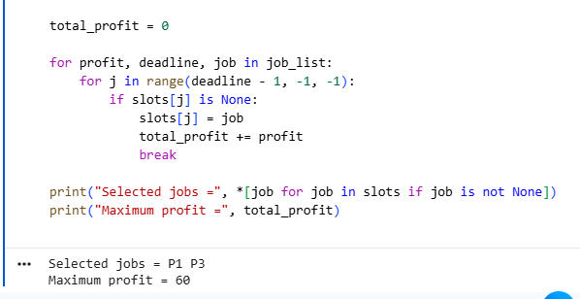Aim
To schedule freelance projects before their deadlines to obtain maximum income.

Algorithm
- Sort projects by decreasing profit.
- Create time slots based on the maximum deadline.
- Schedule each project in the latest free slot before its deadline.
- Add the profit of each selected project.
- Print the selected projects and maximum profit.

Result
The selected projects are P1 and P3, giving a maximum profit of 60.

